SPAULDING TOWNSHIP UPDATE Summer 2025
News from our Supervisor…..
We’re geared up for this summer’s community activities! Wednesday Nights in the Park series featuring live entertainment, food trucks, face painting, antique car, truck and bike show, family fun and raffles will be held at Spaulding Twp. Park, 5825 Cole Rd. on the following Wednesdays with gates opening at 5:30 pm:
July 23 * July 30 * August 6 * August 13
The alternate rainout date for the above is August 20.

May 12th was our annual Roadside Cleanup Day. An impressive group of twenty-seven Bridgeport-Spaulding High School students were bused to Spaulding Park for the morning. The students worked hard, and we cleaned roadsides on M-13 from Evon to Huntington, on S. Washington to St. Anthony’s Church, and on Sheridan Rd. from S. Washington to Williamson roads.

Two of our five Outdoor Food Giveaways have already taken place; the remaining will be offered on the Saturdays of July 26, Sept. 27, and Nov. 22 with distribution starting at 9:30am at the Spaulding Township Community Center & Rental Hall, 5825 Cole Rd. in partnership with Eastern Michigan Food Bank and Center of HOPE Food Pantry. Spaulding Township’s Event & Action Committee extend a big thank you to Frankenmuth Credit Union’s Foundation for Our Communities Feel the Warmth Campaign for their very generous sponsorship, helping make great things like this happen!

Are you up for a game of pickleball? Well, you will be able to feed your hunger soon. We are working on lining and painting the cement slab at our park where the ice rink sits in the winter. There will be four playing fields; the project will take some time but should be ready for competition by end of summer. This all is made possible by generous sponsors of the Event & Action Committee efforts to improve community. Shuffleboard is also available at the park for your gaming pleasure and was created a few years ago by volunteers.

Road projects this year include the standard chip and seal, and major work on Youngstown Place with the Saginaw County Road Commission installing new storm sewers and culverts.

Work constantly takes place searching for and applying for grants to improve our township and the lives of the residents. Most recently, we applied and were accepted through the first step of a lengthy process for a Community Development Block Grant (CDBG) through Michigan State Housing Development Authority (MSHDA). Our grant writer Patty Davidson is working hard along with our dedicated office staff to procure this $300,000.00 grant for Spaulding Township home repair projects for low and moderate-income homeowners. We have more paperwork to submit, but we speculate acceptance by or prior to September 17th and will then reach out to our community and have applications available. So, stay tuned for more information.

If you ever have questions or concerns, please don’t hesitate to call. We, the Board, are here to serve you.

– Ed Masters, Township Supervisor

2025 SUMMER TAXES
Enclosed is your 2025 Summer Tax bill with a due date of Mon., September 15, 2025, to avoid late fees.

If you qualify for a summer tax deferment, forms are available in the township office or on our website. Forms must be submitted by Sept. 15.

To pay your taxes, you may mail a check/money order, place payment in the locked drop box outside, or with cash in person at the township office. If possible, please have correct change when paying cash & your statement with you.
Taxes may also be paid by credit/debit card (including access fee) on the township website.

NOTE:
Property Taxes and Water Dept. are individual entities so you must write separate checks for each payment.

Office Hours: Mon., Tues., Thurs. 10:00am-3:00pm
Wed. from Noon-5:00pm.
Please make checks/money order payable to:
“SPAULDING TOWNSHIP”.

- Tiffany Fortier, Treasurer

BOARD OF REVIEW
Pursuant to provisions of MCL 211.53b, Spaulding Twp. Board of Review will meet on Tuesday, July 22, 2025, at 1:00pm in the Township Complex, 5025 East Rd., Saginaw, MI. The purpose of this meeting is to correct clerical errors or mutual mistakes of fact and to hear poverty exemption applications.


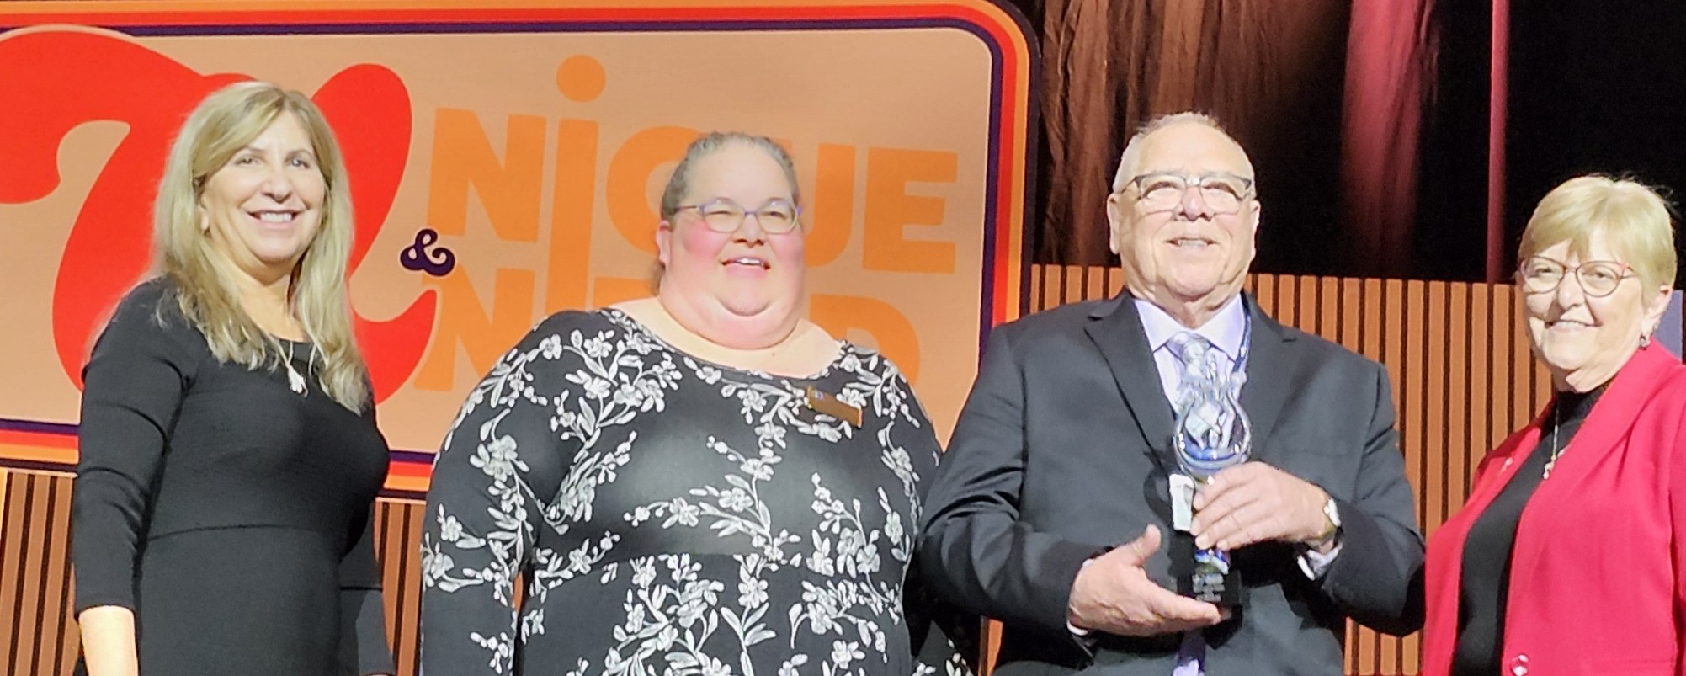




NEWS RELEASE – Congratulations to Spaulding Twp.!
Ed Masters receives ‘Spirit of MTA’ Award

Ed Masters, Spaulding Township (Saginaw Co.) supervisor, has been honored by the Michigan Townships Association with a 2024 “Spirit of MTA” award. The award was created to highlight and recognize the exemplary efforts of local leaders in serving and advancing their township—as the Association has done for more than 70 years. Masters was presented with the award before nearly 1,000 of his township peers on April 2 during an awards ceremony at the banquet held during MTA’s Annual Educational Conference & Expo in Grand Rapids.

“I am humbled and very proud to receive this award,” said Masters, who has served as supervisor since 2016. “When I became supervisor, I surrounded myself with great people and a great township team. We are public servants—we love our community. It’s people helping people. And if we keep that in mind, we will continue to grow and be a success in Michigan.”

Following a statewide call for nominations, Masters was selected by a panel of his fellow township officials, who also served on the MTA Board of Directors, following evaluation and consideration of dozens of nominated elected officials—each of whom represented dedication and above-and-beyond efforts on behalf of their community. Nominations were asked to convey how the official’s leadership style aligns with the 2025 MTA Conference theme of “Unique and United,” representing both the individuality and collective strength of Michigan’s townships. Masters received nominations from three separate individuals in his community—a recognition of the respect he has earned from those with whom he serves.

“Ed prioritizes helping his residents in any way that he can, working to unify his community and bringing residents together, in celebration and in community,” said 2024 MTA President Connie Cargill, who presented the ‘Spirit of MTA’ award to Masters. “He exhibits a unique form of leadership, and has a firm belief that in working together, we all become stronger and better able to improve the lives of our residents and community.”

MTA represents more than 99% of Michigan’s 1,240 townships and is the largest municipal association in the state. Its members include more than 6,500 elected township officials, and tens of thousands more appointed officials, personnel and volunteers.
 Saginaw’s YMCA MISSION NUTRITION minivan will be at our township park from Noon-12:45 every Monday from June 23 – August 11. Parents/caregivers can pick up free 7-day meal bundles for kids which include 7 breakfasts and 7 lunches. Children do not need to be present at the time of pick up and this service is free for all youth 18 years and younger. Visit www.saginawymca.org/mission-nutrition for details.

++ FIRE DEPARTMENT ++

A big thank you to the Saginaw 100 Club for their generous $3,000 grant to help us purchase essential fire equipment—your support means the world to us! We’re also proud to congratulate Maggie Wazny on completing Fire Academy and officially becoming a certified firefighter—well done, Maggie! Be sure to stop by and see us at the Wednesday Night in the Park concerts—we’ll be hosting a 50/50 raffle near the food trucks. Lastly, if you or someone you know is interested in serving the community, we’re actively looking for new firefighters to join our department!
– Thomas Fortier, Fire Chief
____________________________________________________________

Thank you for your generosity!
Event & Action Committee 2025 Calendar of Event

WATER DEPARTMENT
You should have received the annual Saginaw Region Drinking Water Quality Report for 2024 in the mail. Full copies of the report are available in the township office lobby, or you may view the report online at www.saginaw-mi.com/ccr.

Water bills are mailed quarterly at the beginning of January, April, July, and October of each year. So, if you do not receive a bill in the mail by the middle of that month, please contact us so we can provide you with the amount due. IMPORTANT REMINDER, failure to receive a bill does not waive past due penalty or avoid shut off so it’s important that you contact us if you didn’t receive your bill in the mail.

